**Mason Buff**

**9/5/2023**

**BUS 441 Assignment 1**

**Part 1:**

1. My laptop is connected to the internet via Wi-Fi. I have no ethernet port on my laptop.
2. I am located at my house with 4 roommates just off campus on Gorman St.
3. Our ISP is Spectrum
4. I am operating on Windows 11.

**Part 2:**

**Section 1: Practice with Command Basics**

* **Step 30:**

* A computer screen shot of a black screen

  Description automatically generated**Step 61:**

**Section 1: on your own**

**1.** Use the command prompt to navigate to your Desktop folder and list the contents of that folder. Only display the names of the files. Take a screenshot that shows your command and the output. (If you have no files in your Desktop folder, navigate to your Documents folder or your Downloads folder instead).

**2.** Use the command prompt to list the contents of your Desktop folder in order from the smallest file to largest file. Your output should display the date, time, size and filename. Take a screenshot that shows your command and the output. (If you have no files in your Desktop folder, use your Documents folder or your Downloads folder).

**3.** While using the command prompt, make a new subfolder in your Desktop folder (replace Earp with your last name) called **Earp441**. List the contents of the Desktop folder again (this is to confirm you actually created the folder).

**4.** Using the command prompt, remove the folder called **Earp441**. List the contents of the Desktop folder again (this is to confirm that you actually removed the folder).

**Section 2: practice with IPCONFIG**

* **Step 17:**

**Section 2: On your own**

1. Use a command to find the IP address, physical address and default gateway you are currently using. Take a screenshot that clearly shows the command and output.  Circle your active IP address and Physical address on your screenshot.  Also circle the IP address of your default gateway.

1. Is your IP address a private IP address? How do you know? My IP is private. As you can see it is 192.168.1.1 which is, as we talked about in class, a private IP.
2. What is a default gateway (you just learned this)? It is “the computer that connects you to the internet.”
3. What is the IP address of your DNS server(s)? The IP address of my DNS is also 192.168.1.1
4. Use a command to renew your IP address. Use another command to display your lease information. Take a screenshot that shows both commands and the output.

**Section 3: Practice with PING**

* **Step 17:**

**Section 3: On your own**

1. Use the command line to ping [www.osu.edu](http://www.osu.edu)  then use the time command to add a timestamp. Take a screenshot that shows your commands and the output.

1. What is the IP address of the hostname you pinged?

3.161.163.67

1. How long did each ping take?

1st one took 60ms 2nd one took 36ms 3rd one took 28ms 4th one took 31ms.

1. Circle the TTL value on your screenshot.  What does that value tell us?

TTL Value determines how many hops (routers or devices) a packet can travel before it is discarded.

1. Use a command to ping [www.osu.edu](http://www.osu.edu) 8 times then use the time command to add a timestamp. Take a screenshot that shows your commands and the output.

1. Use a command to ping [www.osu.edu](http://www.osu.edu) with 65 byte packets. Take a screenshot that shows your command and the output.

1. Use a command to ping 127.0.0.1. Take a screenshot.

This is the IP address of the local host, known as the loopback address. How long did it take to ping the loopback address? It took no time at all. Considering the ping was just going from my computer to my computer as talked about in class.

**Section 4: Practice with TRACERT**

* **Step 11.**

This trace is different in that it doesn’t include a server at each hop. All we can see from this one is the time for each hop as well as the IP address for each hop.

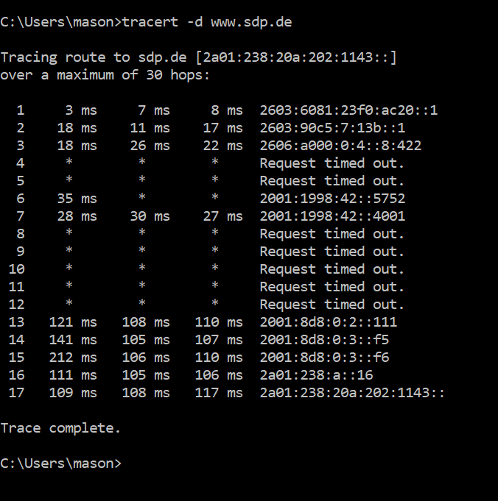

**Section 4: On your own**

1. Use the command line to trace the path between your computer and the webserver for **www.ratm.com**. Take a screenshot that shows your command and the output.

1. How many hops did it take to get to the webserver for **www.ratm.com**?

It took 15 hops to reach the webserver.

1. In the trace to **www.ratm.com**, what is the IP address of the first device after your computer (i.e. the first hop)? What kind of device do you think is the first hop device?

As seen in screenshot, I am doing this section on campus, so my IP is 10.155.0.3. The first hop to a different IP address is 10.250.137.5 which is likely a server here at NC State.

1. Trace the path from your computer to **www.sdp.de**.  Take a screenshot. that shows your command and the output. Circle the hops where the packets go from the US to another country.

1. (a) How many hops did it take to get from your computer to **www.sdp.de** ?   (b) How can you tell when the route jumps from the US to another country (hint: there are 2 things in the output that can help you figure this out)?

It took 15 hops to get to [www.sdp.de](http://www.sdp.de). (b). the reason I could tell when it left the US is because it was in Washington, then it timed out and went to “Frankfurt” which is a city in Germany. The IP addresses also changed.

**Section 5: Practice with NSLOOKUP**

**Section 5: On your own**

1. Use nslookup to find the IP address for www. utexas.edu. Take a screenshot that shows your command and the output.  Circle the IPv4 address for [www.utexas.edu](http://www.utexas.edu).

1. Use another command you learned to confirm this is really the IP address for [www.utexas.edu](http://www.utexas.edu). Take a screenshot that shows your command and the output.

1. Use nslookup to find the IPv4 address of **www.wral.com**. Take a screenshot that shows your command and the output. Why are there multiple IP addresses associated with **www.wral.com**? There are multiple IP addresses because this is a country wide weather website and they likely have multiple locations for each of their main stations.

1. In the example screenshot in Figure 17, why did Nslookup query **vrd1.ddi.ncsu.edu** instead of querying [www.gatech.edu](http://www.gatech.edu) directly?

The reason it queried the ncsu website first is likely because that is our local DNS server. It needs to go to this location first to get the multiple IP addresses for the wral.com website.

**Section 6: Practice with ARP**

* **Step 11:**

**Section 6: On your own**

1. **Explain** what was happening when you used the arp commands in *Section 6: Practice with ARP.* Specifically in Step 3, Step 5, Step 7 and Step 9.

When typing the command “arp -a” we are requesting the computer to display the ARP cashe. When using the command “arp -s 10.0.0.2 11-22-33-44-55-66” we are manually adding an ARP entry to our cashe. Lastly, when using the “arp” with a “-d” at the end, we are deleting a specific ARP entry.

1. Use the screenshot from your arp command in Step 11. Did you see any Multicast Addresses in your ARP cache? Circle them on your screenshot.

**Section 7: Practice with NETSTAT**

**Section 7: On your own**

1. How many TCP processes do you see? Take a screenshot that shows the command and most of the TCP output.

There is roughly 50 processes. The screenshot doesn’t include them all.

